**2023 Unified Umpires Association of Southern New Jersey**

**Scholarship Golf Outing**

**Valley Brook Country Club (Blackwood, NJ)**

**Tuesday August 8, 1:00 pm (Registration at 12:00 noon)**

Shotgun Start * 4-Man Best Ball Scramble Format

Long Drive & Closest to Pin Prizes * 50/50 * Chinese Auction * Door Prizes

**Tournament followed by Dinner at 6:00 PM**

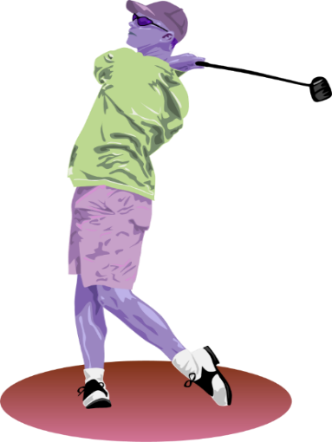**MENU INCLUDES**

Two Entrees

Toss and Caesar Salad

Two Vegetables

Rolls & Butter

Coffee/Tea, Fountain Drinks

**GOLF & DINNER** $120 per player

**DINNER ONLY** $35 per guest

**FOURSOME With HOLE SPONSOR** $530

**TO RESERVE TICKETS or INFORMATION**

**Call** (856)227-1338

**EMAIL** [UUASNJ@UUASNJUMPIRES.COM](mailto:UUASNJ@UUASNJUMPIRES.COM)

**PAID REGISTRATION CUT OFF DATE JULY 31**

**------ * -------* ------*-------*------*------- Please fill out and detach this portion ------****\*-------*------*-------*------*-------**

**Golfer 1 _________________________________________________________________ Fee $__________**

**Golfer 2 _________________________________________________________________ Fee $__________**

**Golfer 3 _________________________________________________________________ Fee $__________**

**Golfer 4 __________________________________________________________________ Fee $__________**

**Dinner ONLY Reservations For: _________________________________**

**Number for Dinner Only Reservations: _______ Fee $ __________**

**TOTAL PAID $______________________**

**Please fill out for hole sponsorship & email a JPEG file of company logo**

**I would like to be a Hole Sponsor for $100.**

**I would like to be a Prize Hole Sponsor for $150.**

**Company Name: ________________________________­­­­­__________________ Phone # ___________________**

**Contact Name: ___________________________________**

**MAKE CHECKS PAYABLE TO** Unified Umpires Association of Southern New Jersey

**MAIL TO** Fred Fortier, 2826 Centre St Pennsauken, New Jersey 08109